# **Coal Energy Balance 2017**

## Main data sources

The South African Coal Energy Balance was constructed using The Department of Mineral Resources and Energy (DMRE) 2017 energy balance [1] as a starting point. However, since discrepancies existed and gaps lay within this data set, the DMRE balance was combined with other sources of information and data to capture the best available information and ensure that all the coal in the system was accounted for. The main additional data sources used in the energy balance development included:

* 2017 Supply and Use Tables (SUT) from StatsSA [2]
* 2017 XMP Consulting [3]
* CSIR solar study
* 2017 Department of Forestry, Fisheries and Environment (DFFE) Green House Gas National Inventory [4]
* Eskom Integrated Report 2018/2019 [5]
* National Business Initative (NBI) [6]
* South African Mining Industry (SAMI) part of DMRE [7]

## Assumptions made

To develop the completed coal energy balance, various assumptions were made. These are listed below:

* The “SUT 2017” sector demand values (in million Rand) included trade and transport margins.
* The SUT “FerroAlloys” sector demand included PGM.
* The SUT “Residential” sector demand (in mton) was assumed based on the ESRG, DMRE and DFFE’s current estimates since this was not available from the SUT raw data.
* Assumptions were made to establish the calorific value (CV) of coal (MJ/kg) for each of the considered sectors. CV data for Eskom, Sasol and the chemicals sectors were available. Coal CV’s for the remaining sectors were assumed based on various factors such as on the generalized grade of coal used within the considered sector. For example, the steel industry generally uses high grade coal whilst the cement industry uses lower grade coal. Then, by using coal price points provided by XMP consulting as a rough guide, estimated coal CV values were set for each sector.
* To determine the price of coal (R/GJ) for each considered sector, the 2017 SUT (which listed the sectorial spend on coal for 2017) was used as a starting point. Energy estimates of some of the sectors in PJ were available and these estimates were reconciled with the SUT data to develop coal prices for these sectors. For sectors where no PJ estimates existed, PJ amounts were inferred by assuming R/GJ values for each sector based on available information. Additionally, assumptions based on the transport costs associated with transporting the coal to the dominant area of the considered sector were used. For example, the coal price for the “Paper and Pulp” sector was higher due to the extra-long distances travelled.
* The total coal supplied from coal mining in 2017 included domestic and export coal sales. The export sales were known. Estimations of the domestic sales were available from SAMI and XMP data and thus the total coal supply for 2017 was estimated to be approximately 181 mton.
* The “Power” sector coal demand for “SATIMGE-2021” was derived from plant output as obtained from NERSA.
* For the “SATIMGE-2022” dataset, the “FerroAlloys” demand (in mton) was adjusted to XMP consulting/ SAMI value of 2.7. The “Paper and Pulp” and “Other Industries” sector demands were assumed to be the SUT demand values. Finally, the “Residential” sector demand was assumed to be an average of the DFFE and DMRE residential sector demands.
* Two data sets from XMP consulting were included since different inaccuracies existed in both sets and thus it was deemed necessary to include both of the versions to account for these.
* For the 2017 XMP coal demand (in mton) in the Energy Balance, the “Pulp_paper323” sector demand was taken from the “Industries” commodity in XMP’s raw demand data.
* The assumed coal demand (in mton) for Eskom in the Energy Balance was based on the 2018/2019 Integrated Eskom report. The demand was calculated using a weighted average of the coal purchase values (in mton) for the 2016/2017 period and the 2017/2018 period as documented in the report.
* For the SAMI 2017 coal demand in the energy balance, the “Iron_Steel351” sector demand included iron, steel and ferroalloy industries from the SAMI raw data.

## Preliminary Energy Balance including all considered sources

Table : Preliminary 2017 Coal Energy Balance



### Adopted Energy Balance as per SATIM sector/ subsector disaggregation

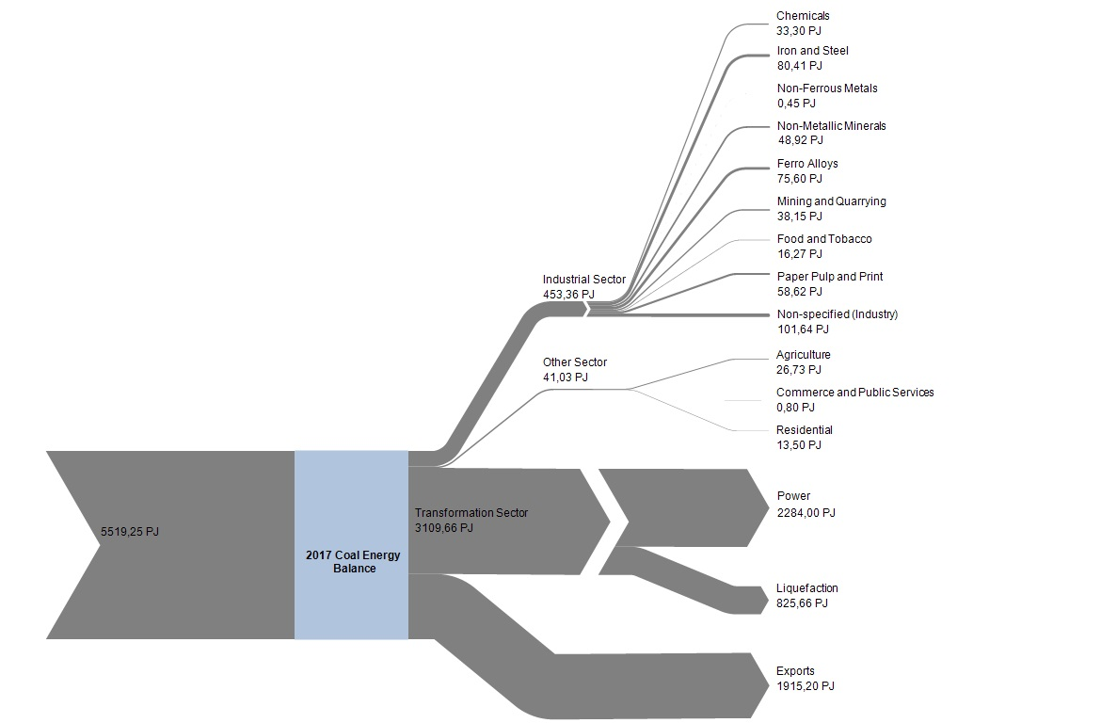

Figure : 2017 Coal Energy Balance Sankey Diagram (PJ)

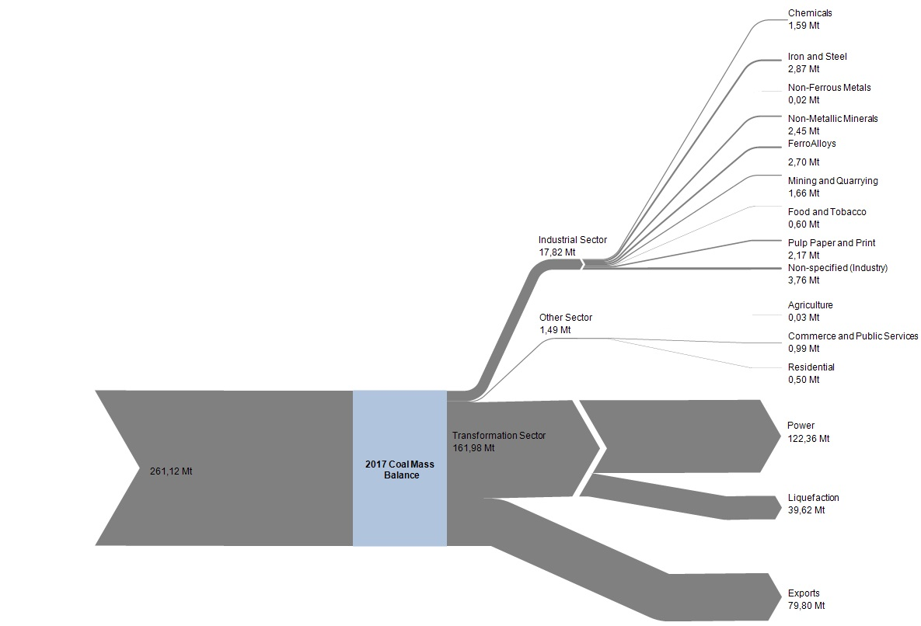

Figure : 2017 Coal Energy Balance Sankey Diagram (Mt)

Table : 2017 Coal Energy Balance SATIMGE-2022



## Identified gaps for future work

To improve on the current coal energy balance, the following gaps were identified to take into consideration for future work:

* More coal use and price data should be collected to ensure better sector allocation and reconciliation with SUT tables. Data on CO2 tax may provide some of this information.
* Consider conducting a provincial disaggregation in order to build a spatially disaggregated model for future.

# References

[1] “DMRE Energy Balance 2017,” 2017.

[2] “Supply and Use Tables 2017,” 2017. [Online]. Available: https://www.statssa.gov.za/.

[3] “XMP Consulting CC,” 2017. https://xmpconsulting.com/.

[4] L. Stevens, “National GHG Inventory Report,” 2017. [Online]. Available: https://www.dffe.gov.za/sites/default/files/docs/nir-2017-report.pdf.

[5] “Eskom Integrated Report.” [Online]. Available: https://www.eskom.co.za/wp-content/uploads/2021/02/Eskom_2019_integrated_report.pdf.

[6] “Climate Pathways and a Just Transition for South Africa,” 2017.

[7] T. Masetlana, K. Revombo, L. Malebo, and R. Motsie, “South Africa’s Mineral Industry 2019/2020,” 2020.

**NOTE**

* 2017 Supply and Use Tables (SUT) from StatsSA CANT FIND PUBLICATION
* 2017 XMP Consulting CANT FIND EXACT
* CSIR solar study CANT FIND
* DMRE 2017 ENERGY BALANCE CANT FIND PUBLICATION